**Press Release**

**Halal Cosmetics and Personal Care Products; A Growing Market**

**Islamabad – June 26, 2025:**

Pakistan Halal Authority (PHA), in collaboration with the Lahore Chamber of Commerce & Industry (LCCI), organized a seminar on ***“Regulatory Framework of Halal Cosmetics and Personal*** *Care* ***Products”*** at the LCCI to raise awareness about requirements for Halal compliance to enable the access of Pakistan’s Halal cosmetics and personal care products in ***USD 127 billion*** global halal cosmetic market.

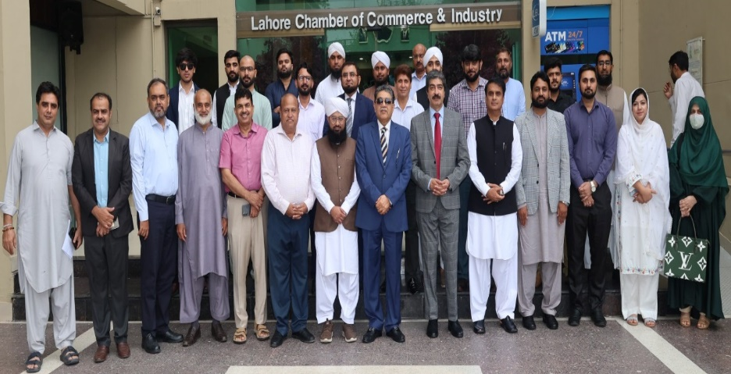This was the first sector-specific seminar beyond the food sector conducted by PHA. The seminar not only aimed to raise awareness about Shariah and standards requirements, the regulatory framework, and global market demands in cosmetics and personal care products but also to discuss the issues and challenges faced by the business sector in uplifting this segment of Pakistan’s industry in the global Halal market.

Mr. Abuzar Shad, President of LCCI, praised PHA’s efforts and emphasized that tapping into the trillion-dollar global Halal market requires effective regulatory frameworks and industry awareness. The DG PHA gave detailed insights into its mandate and key initiatives to facilitate manufacturers, traders, and consumers. He also urged participants to establish quality and Halal assurance systems throughout the supply chain in order to meet the needs and demands of local and global consumer markets. ***“The need for coordination between stakeholders and the authority to resolve regulatory and trade challenges in the Halal cosmetics sector is our keen interest,” said the DG PHA.***

During the seminar, speakers Mufti Sajid and Dr. Saima gave presentations on the importance and impacts of consuming non-Halal cosmetics and personal care products on consumer’s lifestyles. Manufacturers and consumers were also briefed about various critical elements to ensure authenticity and traceability of ingredients, as well as how contaminants in manufacturing and packaging can threaten Halal integrity. Various cosmetics and personal care manufacturers, traders, certification bodies, and academia actively participated.

Mr. Shahid Nazir Chaudhry, Vice President of LCCI, also mentioned that the PHA session was extensively informative and addressed critical issues within the cosmetics sector. He appreciated PHA’s proactive role in enhancing awareness and offered LCCI’s continued support in organizing similar programs to uplift Pakistan’s Halal economy.